I2C (Master & Slave)

Slave

Verilog code

module Slave(

inout wire SDA,

input wire SCL);

reg [4:0] IDLE = 4'b0000;

reg [4:0] START = 4'b0001;

reg [4:0] READ_ADDRESS = 4'b0010;

reg [4:0] READ_WRITE = 4'b0011;

reg [4:0] DATA = 4'b0100;

reg [4:0] DATA_ACK = 4'b0101;

reg [4:0] STOP = 4'b0110;

reg [4:0] ADDRESS_ACK = 4'b0111;

reg [4:0] state = 4'b0010;

reg [6:0] slaveAddress = 7'b000_1000;

reg [6:0] addr = 7'b000_0000;

reg [6:0] addressCounter = 7'b000_0000;

reg [7:0] data = 8'b0000_0000;

reg [6:0] dataCounter = 7'b000_0000;

reg readWrite = 1'b0;

reg start = 0;

reg write_ack = 0;

assign SDA = (write_ack == 1) ? 0 : 'b1z;

always @(negedge SDA) begin

if ((start == 0) && (SCL == 1))

begin

start <= 1;

addressCounter <= 0;

dataCounter <= 0;

end

end

always @(posedge SDA) begin

if (state == DATA_ACK && SCL == 1)

begin

start <= 0;

state <= READ_ADDRESS;

end

end

always @(posedge SCL)

begin

if (start == 1)

begin

case (state)

READ_ADDRESS:

begin

addr[addressCounter] <= SDA;

addressCounter <= addressCounter + 1;

if (addressCounter == 6)

begin

state <= READ_WRITE;

end

end

READ_WRITE:

begin

readWrite <= SDA;

state <= ADDRESS_ACK;

end

ADDRESS_ACK:

begin

write_ack <= 1;

state <= DATA;

end

DATA:

begin

write_ack <= 0;

data[dataCounter] <= SDA;

dataCounter <= dataCounter + 1;

if (dataCounter == 8)

begin

state <= DATA_ACK;

write_ack <= 1;

end

end

DATA_ACK:

begin

write_ack <= 0;

state <= STOP;

end

STOP:

begin

start <= 0;

state <= READ_ADDRESS;

end

endcase

end

end

endmodule

Testbench

module Slave_TB ();

reg clk;

wire SDA;

wire SCL;

pullup(SDA);

pullup(SCL);

reg [6:0] addressToSend = 7'b000_1000;

reg readWite = 1'b1;

reg [7:0] dataToSend = 8'b0110_0111;

integer ii=0;

initial begin

clk = 0;

force SCL = clk;

forever begin

clk = #1 ~clk;

force SCL = clk;

end

end

Slave #() UUT

(.SDA(SDA),

.SCL(SCL));

initial

begin

$display("Starting Testbench...");

clk = 0;

force SCL = clk;

#11

// Set SDA Low to start

force SDA = 0;

for(ii=0; ii<7; ii=ii+1)

begin

$display("Address SDA %h to %h", SDA, addressToSend[ii]);

#2 force SDA = addressToSend[ii];

end

$display("Read/Write %h SDA: %h", readWite, SDA);

#2 force SDA = readWite;

release SDA;

$display("SDA: %h", SDA);

#2; // Wait for ACK bit

for(ii=0; ii<8; ii=ii+1)

begin

$display("Data SDA %h to %h", SDA, dataToSend[ii]);

#2 force SDA = dataToSend[ii];

end

#2;

release SDA;

#2 force SDA = 1;

#100;

$finish();

end

initial

begin

$dumpfile("dump.vcd");

$dumpvars(0);

end

endmodule

RTL

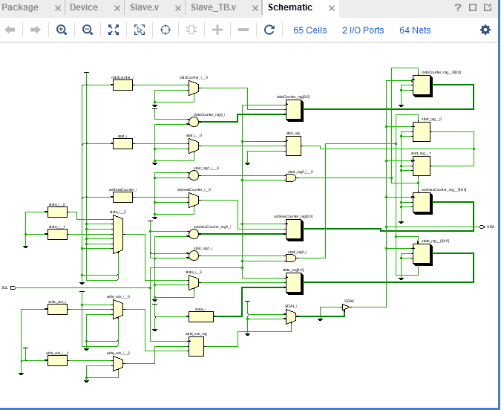

Behavioral Simulation

